A report of activities, Events, awards and achievements (from April 2025 to March 2026)
National High School continued to uphold its tradition of excellence in co-curricular activities during the academic session 2025–26. Students enthusiastically participated in a wide range of inter-school, state-level, national, and international competitions, showcasing their talents in sports, academics, quizzes, olympiads, and other extracurricular fields.
A major highlight of the year was the participation of 15 students in the 9th International Karate Championship 2025 (Indian Challenger Cup) held at Netaji Indoor Stadium, Kolkata, from 25th to 28th July 2025. The students displayed remarkable skill and determination, securing an impressive tally of 18 medals, including 4 Gold, 8 Silver, and 6 Bronze medals. This outstanding achievement brought great pride to the school and reflected the dedication of both the participants and their coaches and 9th West Bengal Inter-School Karate Championship 2025 held at South City International School on 12th January 2025. Students won 4 Gold, 7 Silver, and 8 Bronze medals, further strengthening the school's reputation in sporting excellence.

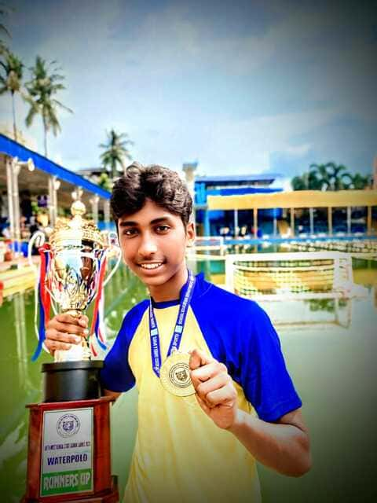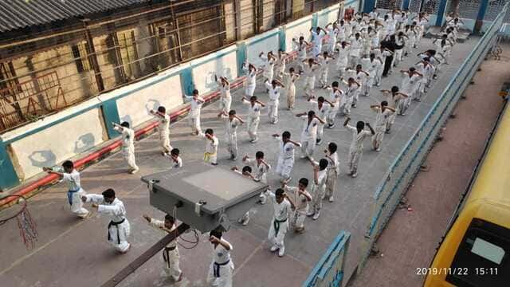

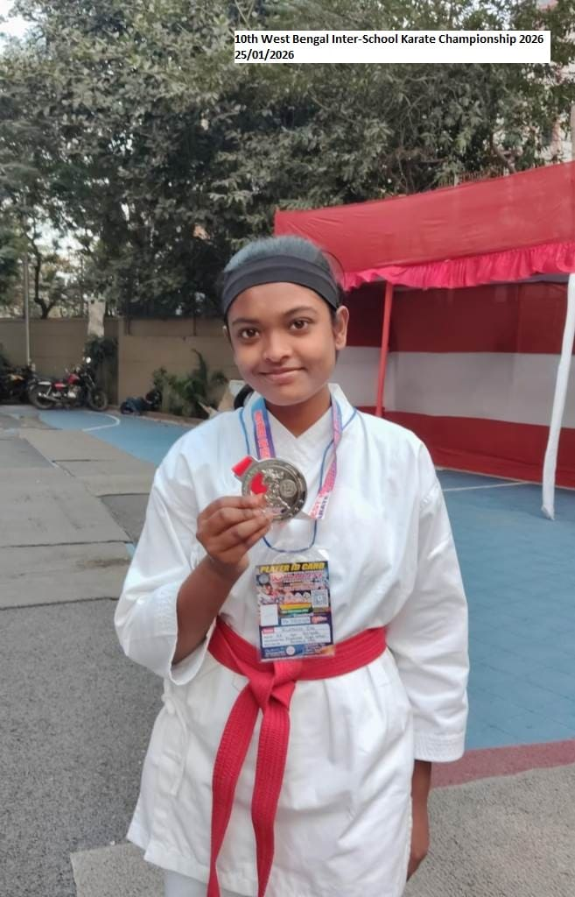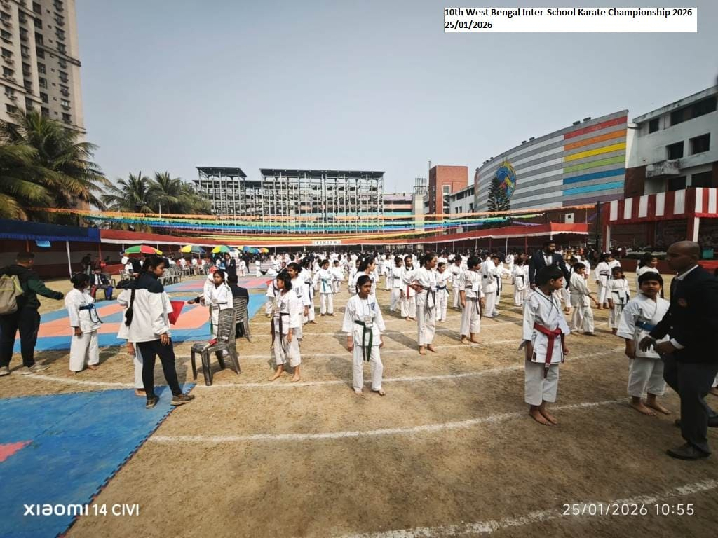

Apart from sports, the students actively participated in various prestigious academic and intellectual events. Students achieved 2nd and 3rd position in MP Birla Memorial Award Programme, 1st position in NSHM TOI Knowledge Quest,2nd position at the State Level in Geeta Chanting organised by Chinmaya Mission, 1st position in Physics DiO Spectra, 1st and 2nd position in Techno Olympica Knights, 3rd position in Quiz Competitions, 2nd position in Rowing events, 2nd position in T-shirt painting at South Point High School and participation in the SilverZone Olympiads. These platforms provided valuable opportunities for students to enhance their knowledge, analytical abilities, creativity, leadership qualities, and team spirit.

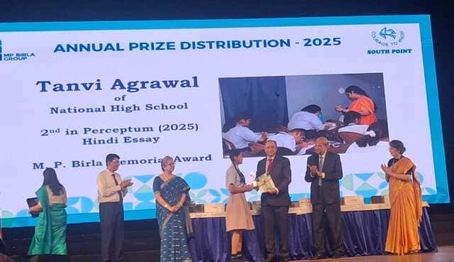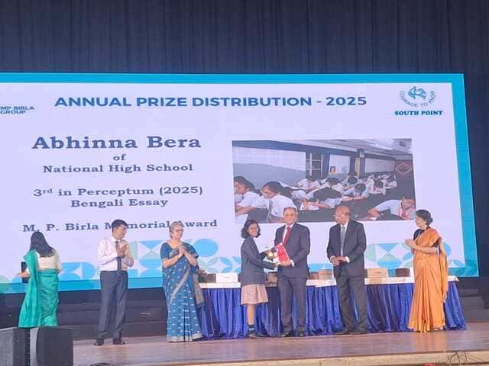

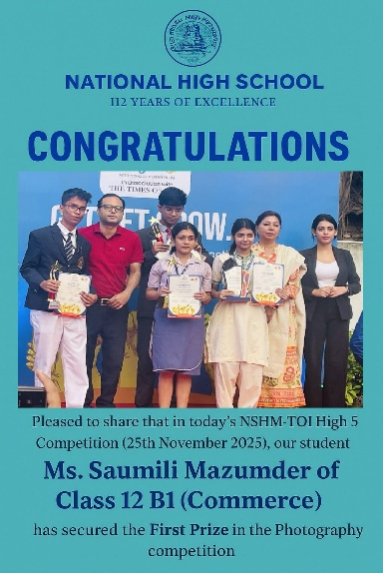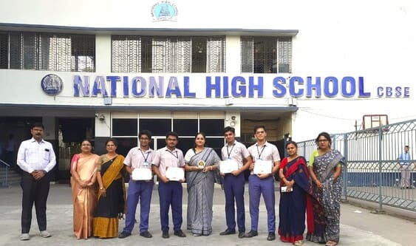

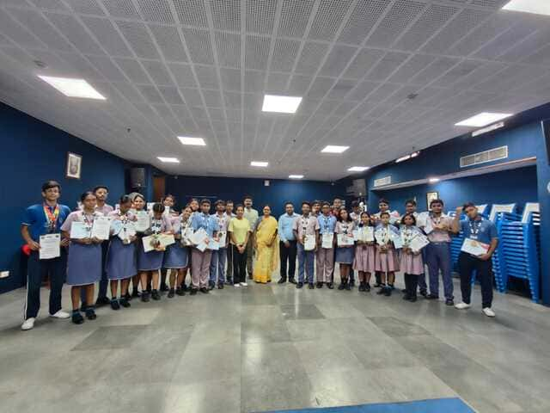
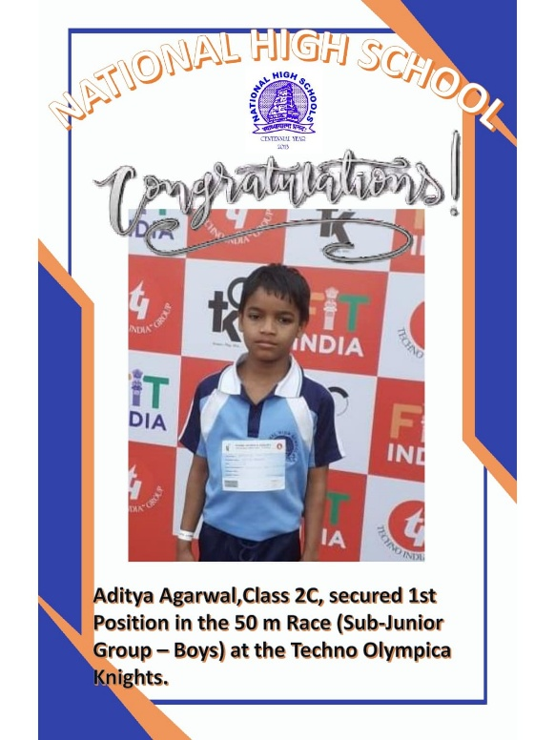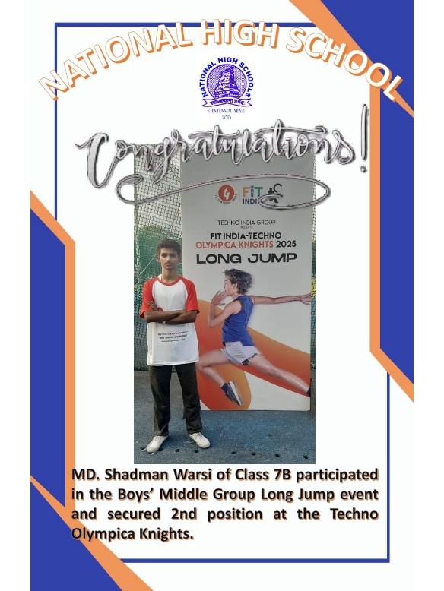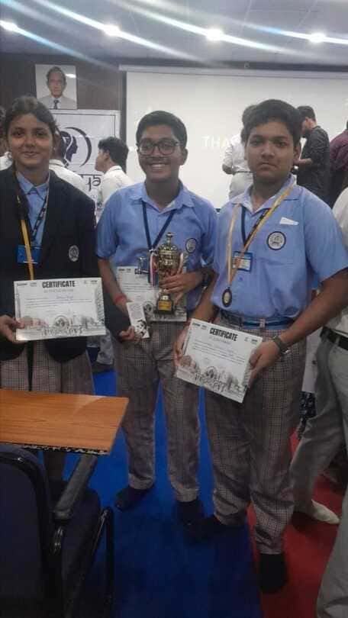

The consistent participation and achievements of students in diverse fields reflect the school's commitment to holistic education and personality development. The school remains dedicated to encouraging students to explore their potential beyond academics and excel in various spheres of learning and competition.

The school organized a wide range of co-curricular and enrichment activities throughout the academic session 2025–26 to promote the holistic development of students. Beginning with Poshan Pakhwara, Earth Day, Eco Mission, Greenery Day, and Yoga Day, students actively participated in programmes focused on health, environmental awareness, and physical well-being. Activities such as Van Mahotsav, Monsoon Walk, Traffic Awareness Week, Water Conservation campaigns, and Health Lifestyle initiatives helped to instill social responsibility and environmental consciousness among learners.
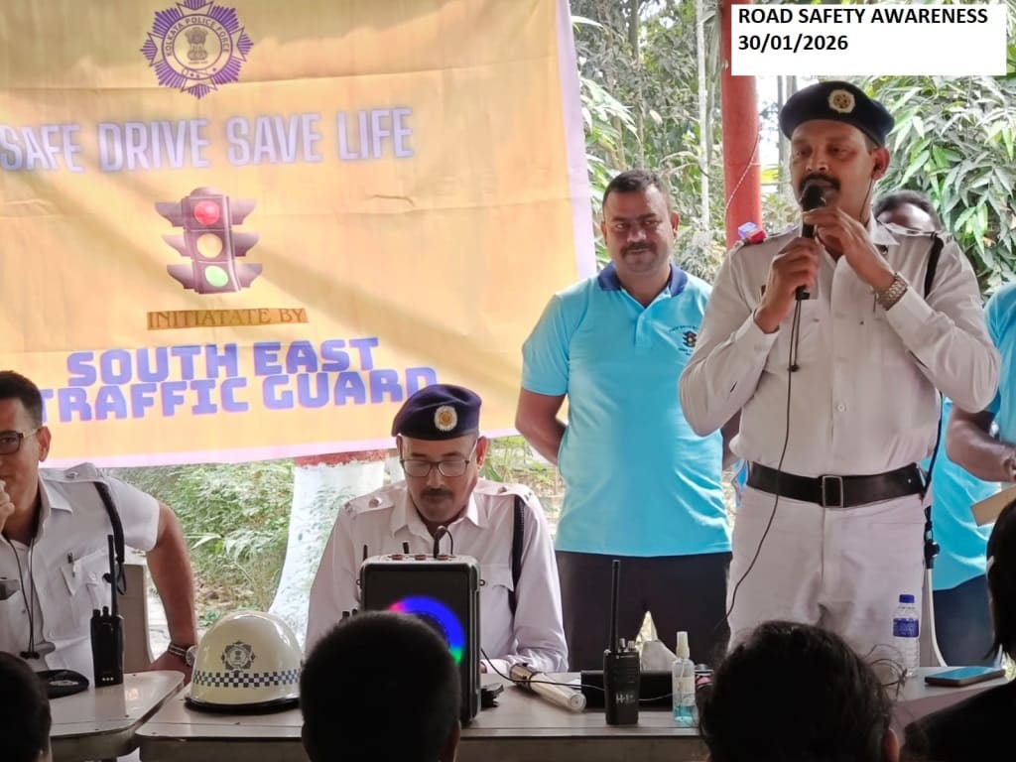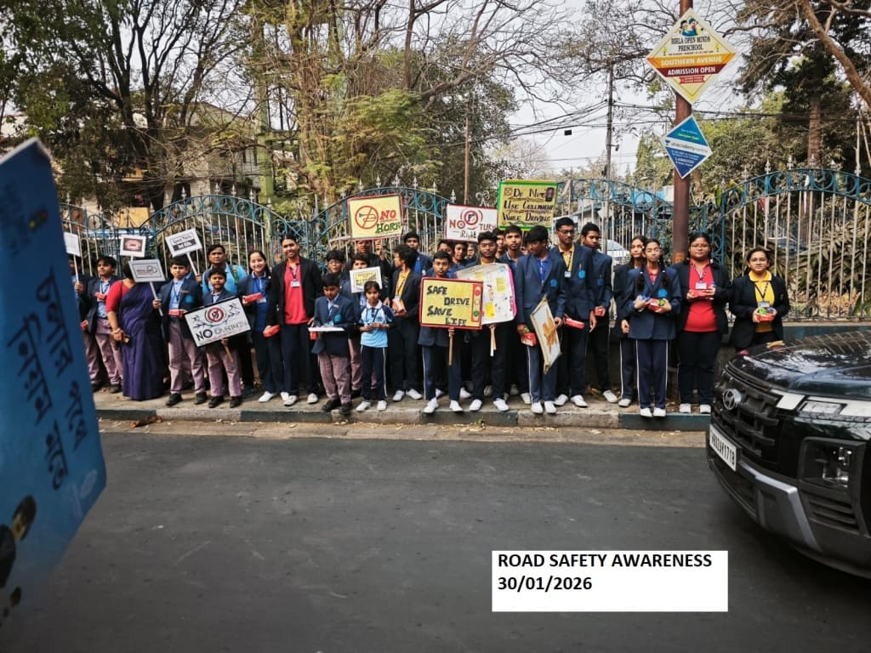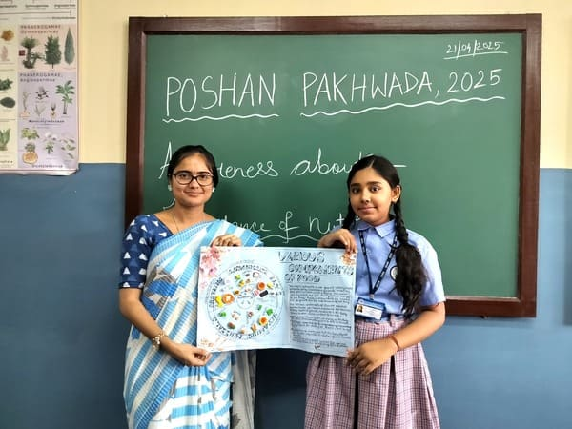
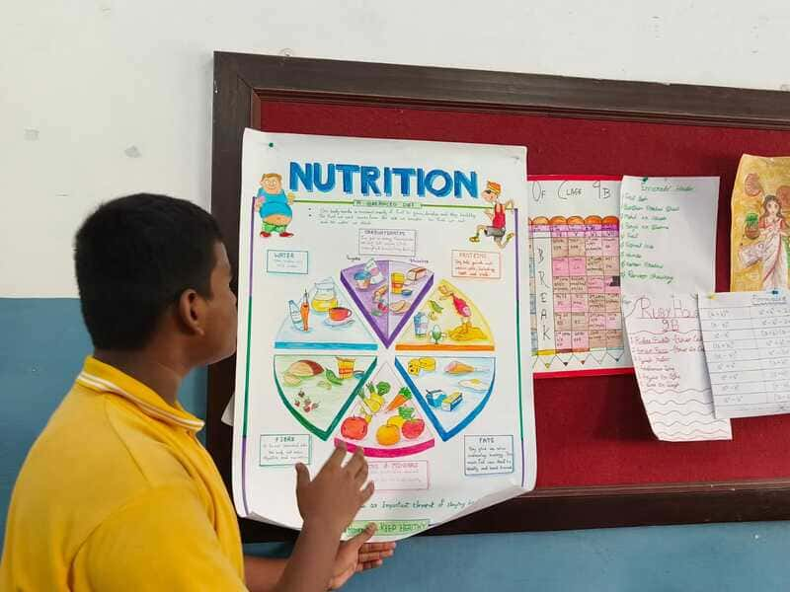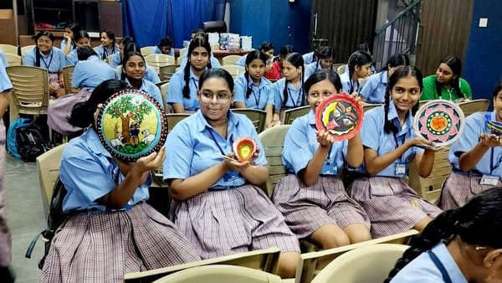

The later part of the session witnessed enthusiastic participation in academic, cultural, and skill-based events including Cyber Safety programmes, Viksit Bharat initiatives, Mental Health awareness activities, Veer Gatha, Aryabhatta Ganit Challenge, Storytelling competitions, Children's Day celebrations, Annual Day, School Picnic, Annual Sports, Saraswati Puja, Republic Day celebration, Pariksha Pe Charcha, and the National Level Aryabhatta Talent Search Test.
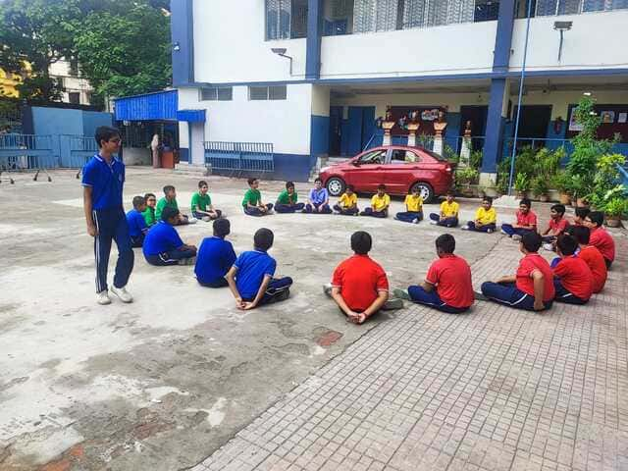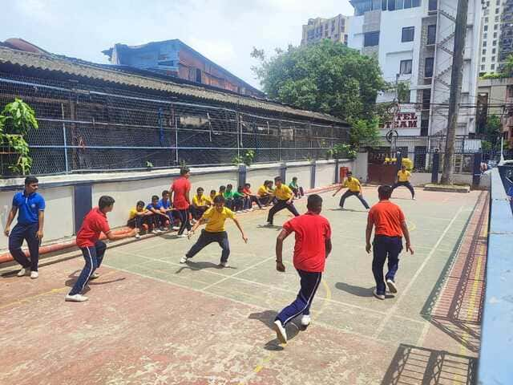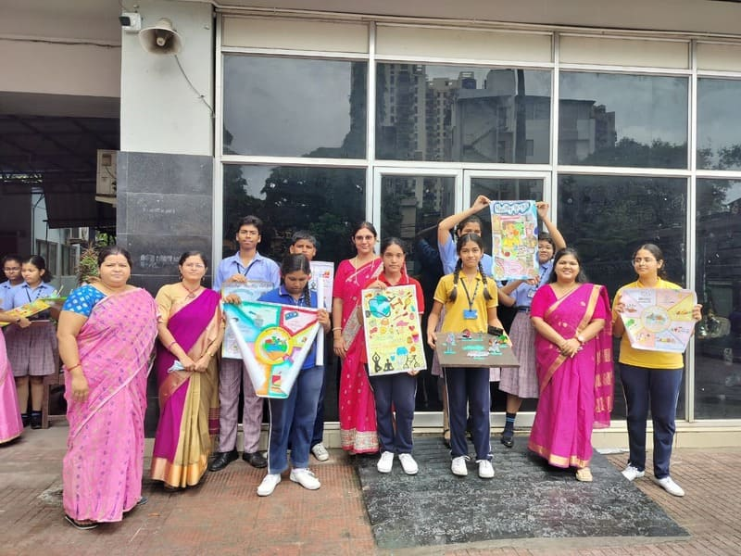
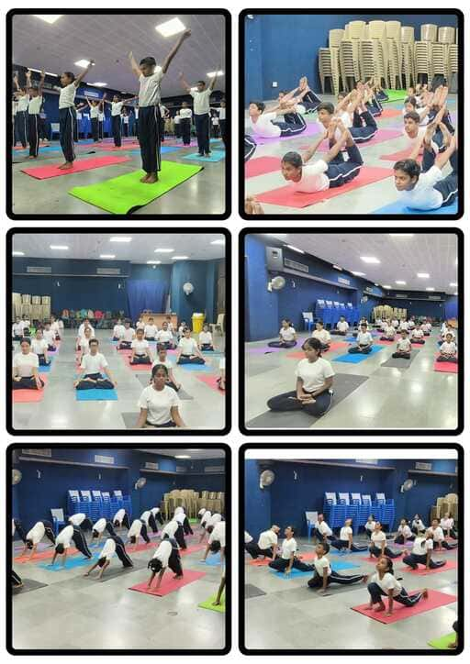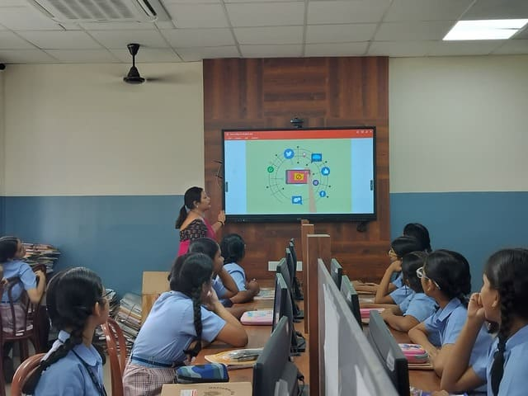
These activities provided students with opportunities to enhance their creativity, leadership, communication, critical thinking, and teamwork skills. The successful conduct of these events reflects the school's commitment to nurturing well-rounded individuals and fostering excellence beyond academics.
The school had also organized Capacity Building Programmes conducted by CBSE for teachers to facilitate pedagogical improvement.
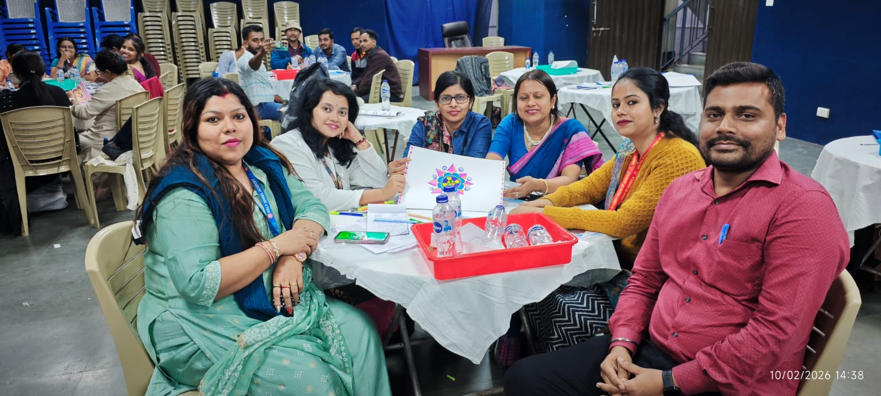
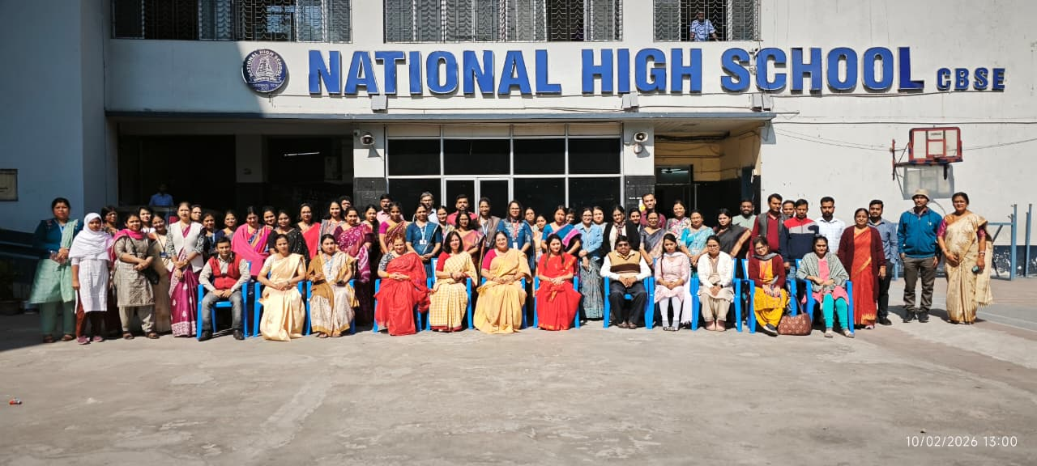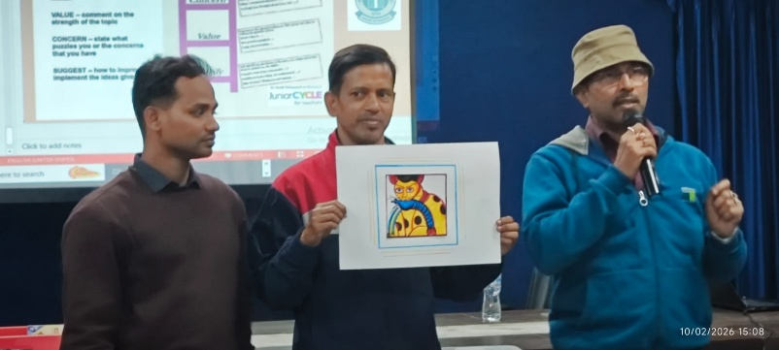
Overall, the session 2025–26 has been highly successful, marked by significant accomplishments, active participation, and numerous accolades. The achievements of our students serve as an inspiration for future batches and reinforce the school's vision of nurturing well-rounded individuals capable of excelling at every level.

